Date access: 2020-03-09

<http://wjw.beijing.gov.cn/wjwh/ztzl/xxgzbd/gzbdyqtb/202001/t20200130_1621757.html>

As of 17:00 on the 25th, 5 new pneumonia cases of new coronavirus infection were added to this city, and 39 people were treated in the hospital.

Date: 2020-01-25 Source: Beijing Municipal Health Committee

As of 17:00 on the 25th, the city has accumulated 41 confirmed cases, including 4 in Xicheng District, 6 in Chaoyang District, 8 in Haidian District, 2 in Fengtai District, 1 in Shijingshan District, 3 in Tongzhou District, 1 in Shunyi District, There were 2 cases in Daxing District, 3 cases in Changping District, and 11 cases came from overseas.

**截至25日17时本市新增5例新型冠状病毒感染的肺炎病例，在院治疗39人**

日期：2020-01-25 来源：北京市卫生健康委‍

        截至25日17时，本市新增5例新型冠状病毒感染的肺炎病例，均已送至定点医疗机构进行救治。目前在院治疗39人。

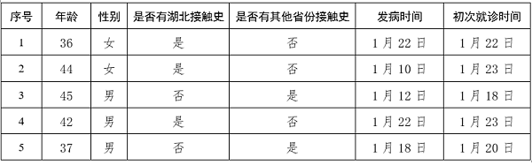

        截至25日17时，本市累计确诊病例41例，其中西城区4例、朝阳区6例、海淀区8例、丰台区2例、石景山区1例、通州区3例、顺义区1例、大兴区2例、昌平区3例，外地来京人员11例。